

**FACULTY OF COMPUTER SCIENCE AND INFORMATION TECHNOLOGY**

**CSC 3402-1 (DATABASE APPLICATION DEVELOPMENT)**

**SEMESTER II 2022/2023**

**PROGRAMME:**

**BACHELOR OF COMPUTER SCIENCE WITH HONORS**

**—------------------------------------------------------------------------------------------------------------------------**

**COURSE: DATABASE APPLICATION DEVELOPMENT**

**COURSE CODE: CSC3402**

**GROUP MEMBERS:**

| **NAME** | **MATRIC NO** |
| --- | --- |
| **BAVAMITHIRAN JEYAPRAGAS** | **210468** |
| **DANESHWAREN RAGUPATHY** | **209858** |
| **THEVANDREN YEGARAJOO** | **212592** |
| **SAHTISH RAO RAMULOO** | **210404** |

1.0 INTRODUCTION

The development of a web-based application for healthcare data management is a significant endeavor with the primary objective of improving the efficiency and accuracy of managing patient information and medication records. By leveraging a well-designed database and intuitive user interfaces, this project aims to streamline the process of registering staff members, recording patient details, and managing prescribed medicines.

To accomplish these goals, the project will involve the development of a web application that incorporates key technologies such as HTML, CSS, JavaScript, and a server-side programming language such as PHP, Python, or Ruby. This combination of technologies will enable the creation of a robust and dynamic user interface that facilitates seamless data storage and retrieval from a database, thereby ensuring quick and efficient access to patient information and medication records.

The web-based application will cater to the needs of doctors, providing them with a comprehensive interface that allows them to register their staff, add patient information, and update medication records securely. Additionally, staff members will have their own authenticated access to the application, granting them the ability to view patient details and prescribed medications within the scope of their authorized responsibilities. The system will enforce role-based access control, safeguarding sensitive information and ensuring that only authorized personnel can perform specific actions such as registering staff or editing patient information.

One of the significant advantages of developing a web-based application is its inherent accessibility. By utilizing the internet as a platform, users can access the system from any device with an internet connection, eliminating the need for specific software installations or device restrictions. This flexibility promotes ease of use and efficiency in healthcare data management, enabling medical professionals to retrieve patient information and update medication records on-the-go or from various locations.

Moreover, deploying the application on a secure server ensures data privacy and compliance with healthcare regulations. By adhering to industry standards and implementing robust security measures, the system will protect sensitive patient information, maintain confidentiality, and contribute to maintaining the integrity of healthcare data.

In conclusion, the development of a web-based application for healthcare data management presents an opportunity to enhance the overall effectiveness of managing patient information and medication records. By leveraging a well-designed database, intuitive user interfaces, and web technologies, the project aims to streamline processes, improve accessibility, and strengthen data security. This project serves as a solid foundation for future enhancements and advancements in healthcare data management systems, ultimately leading to improved patient care and supporting medical professionals in their daily operations.

2.0 DATABASE DESIGN

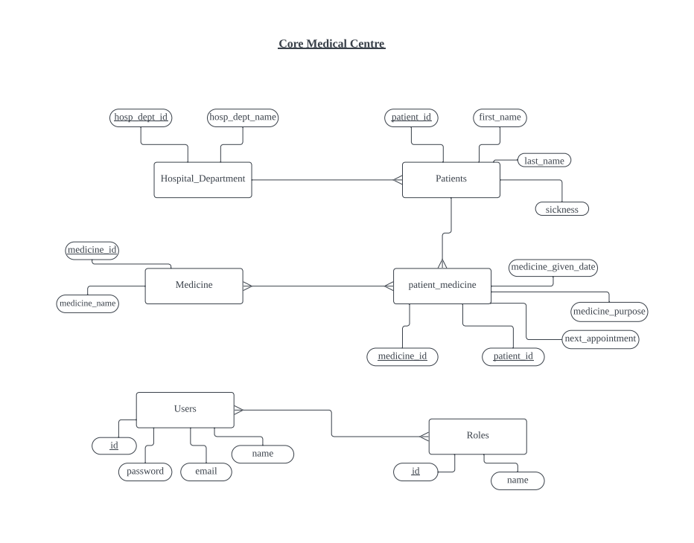

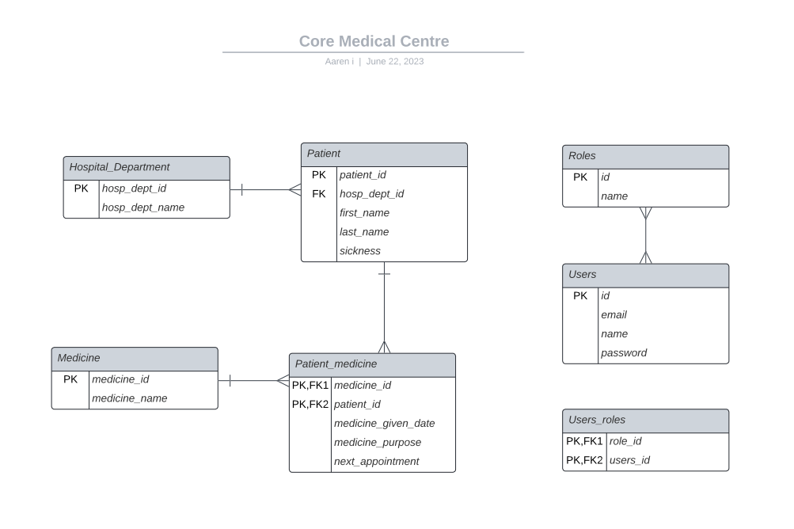

3.0 APPLICATION DESIGN

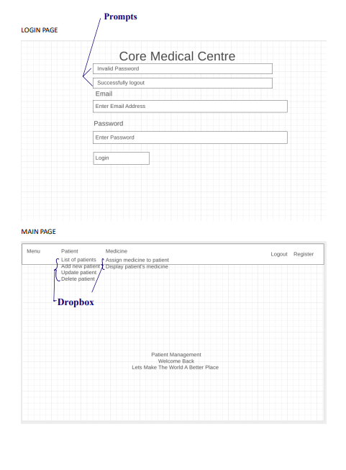

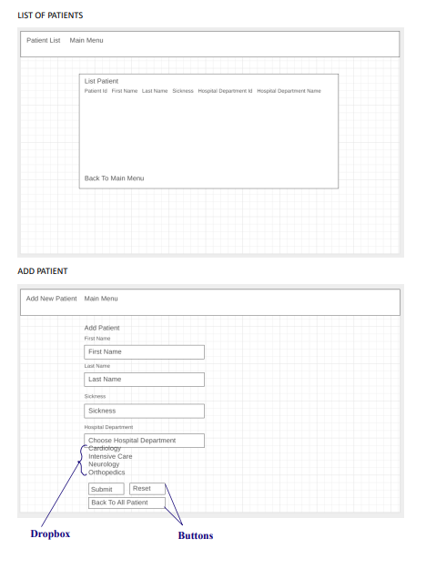

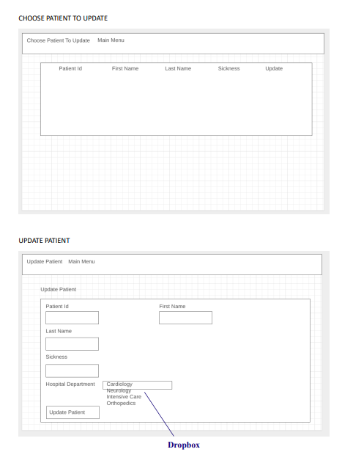

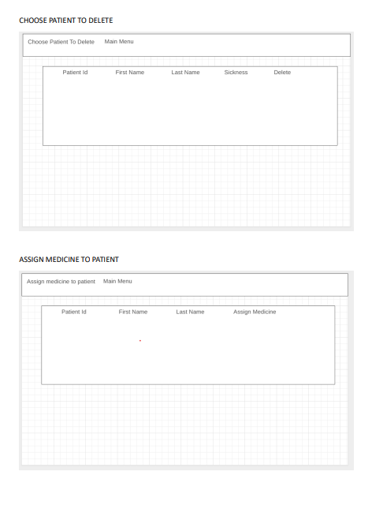

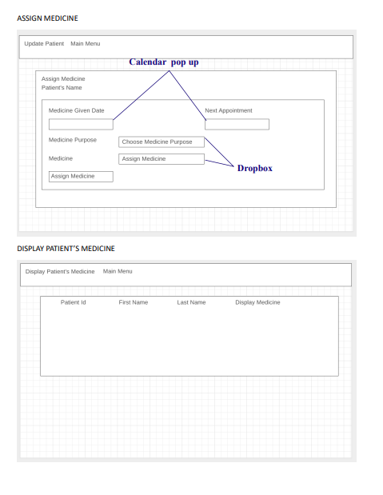

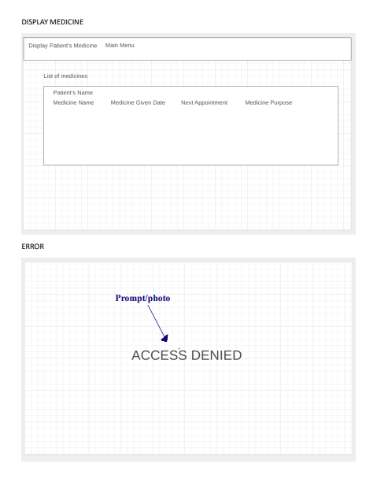

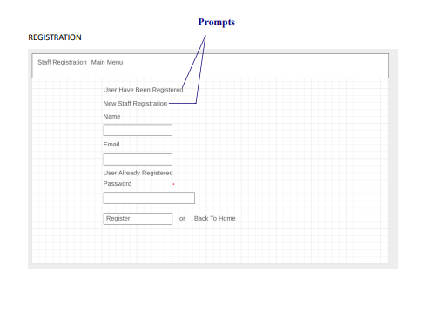

4.0 USER INTERFACE AND TESTING

* Login Page

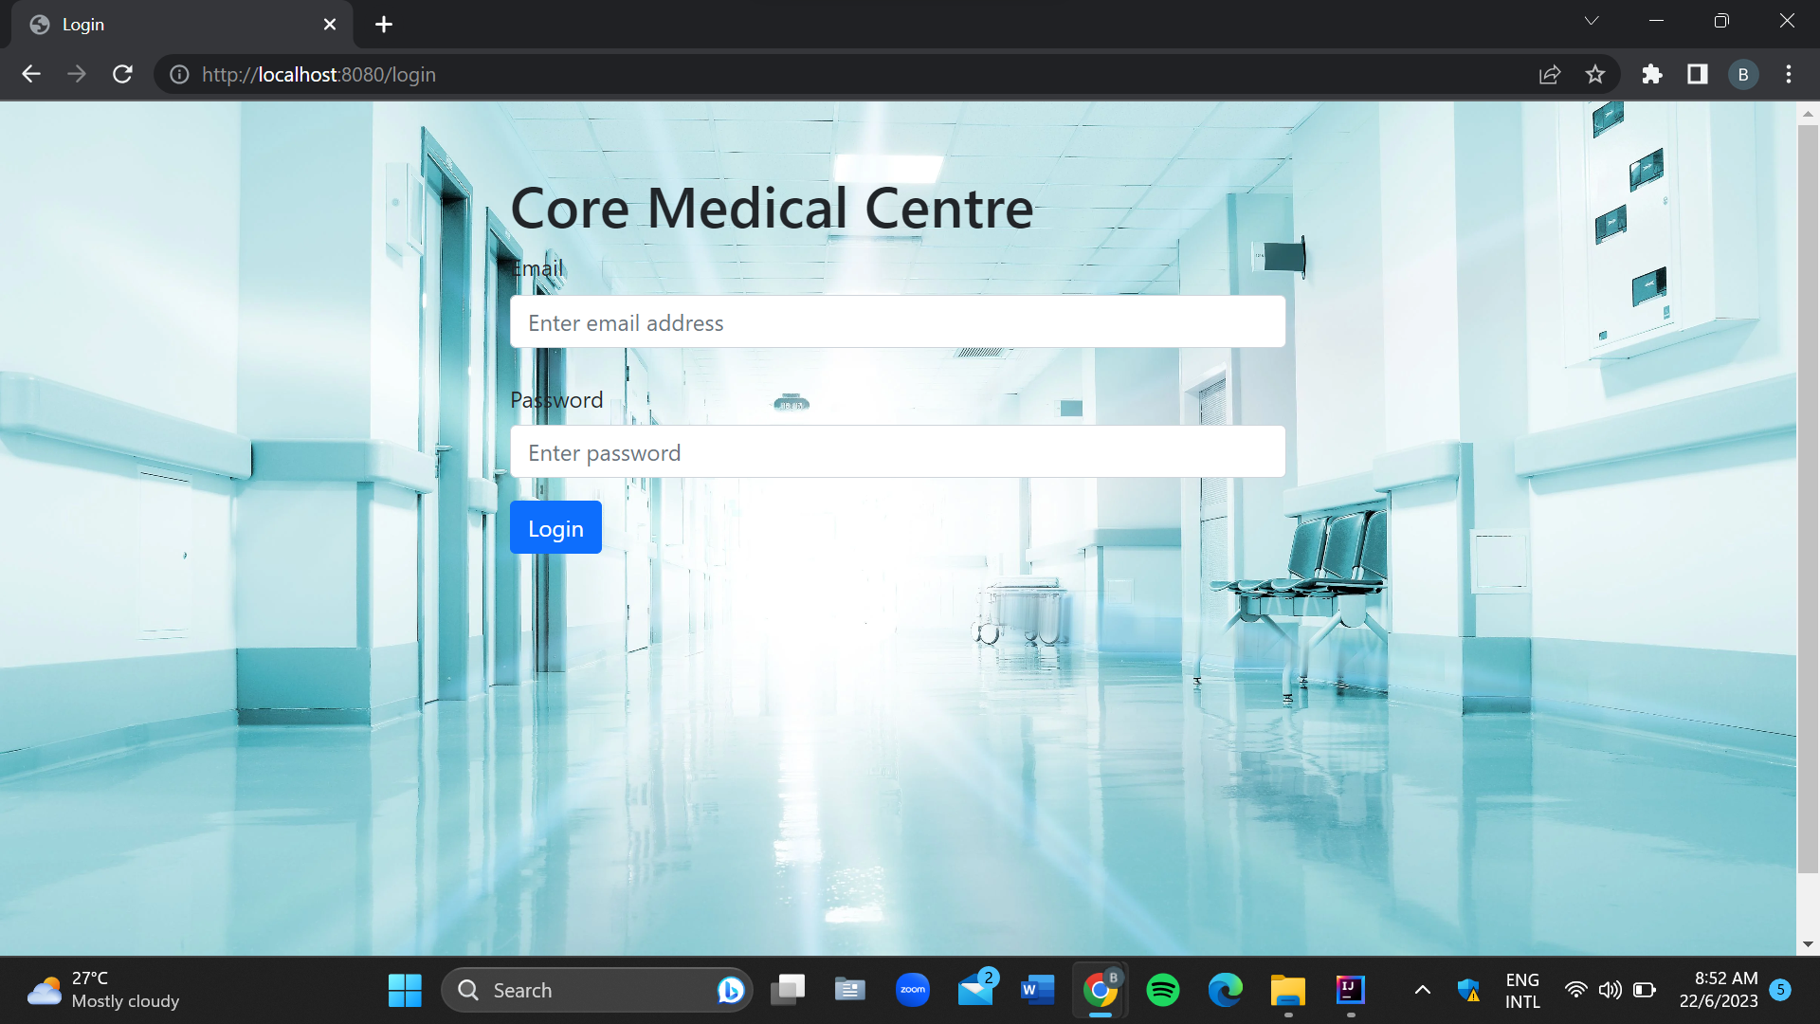

* Index Page

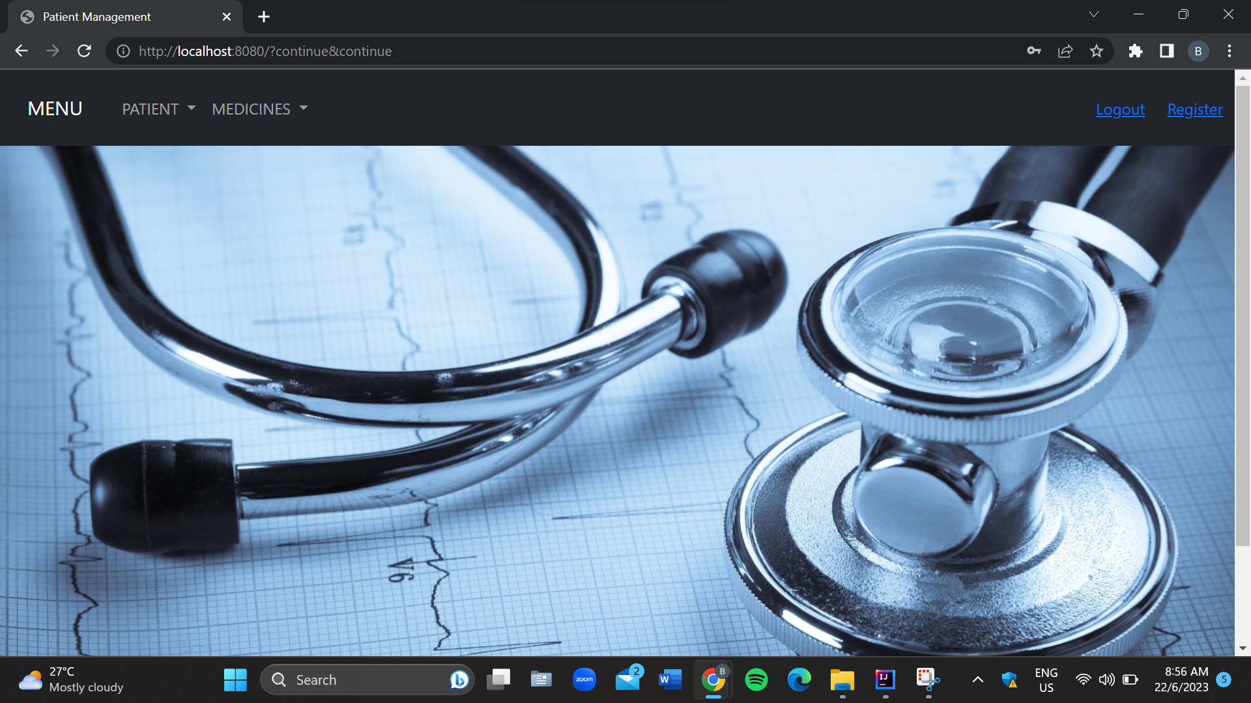

* Registration Page

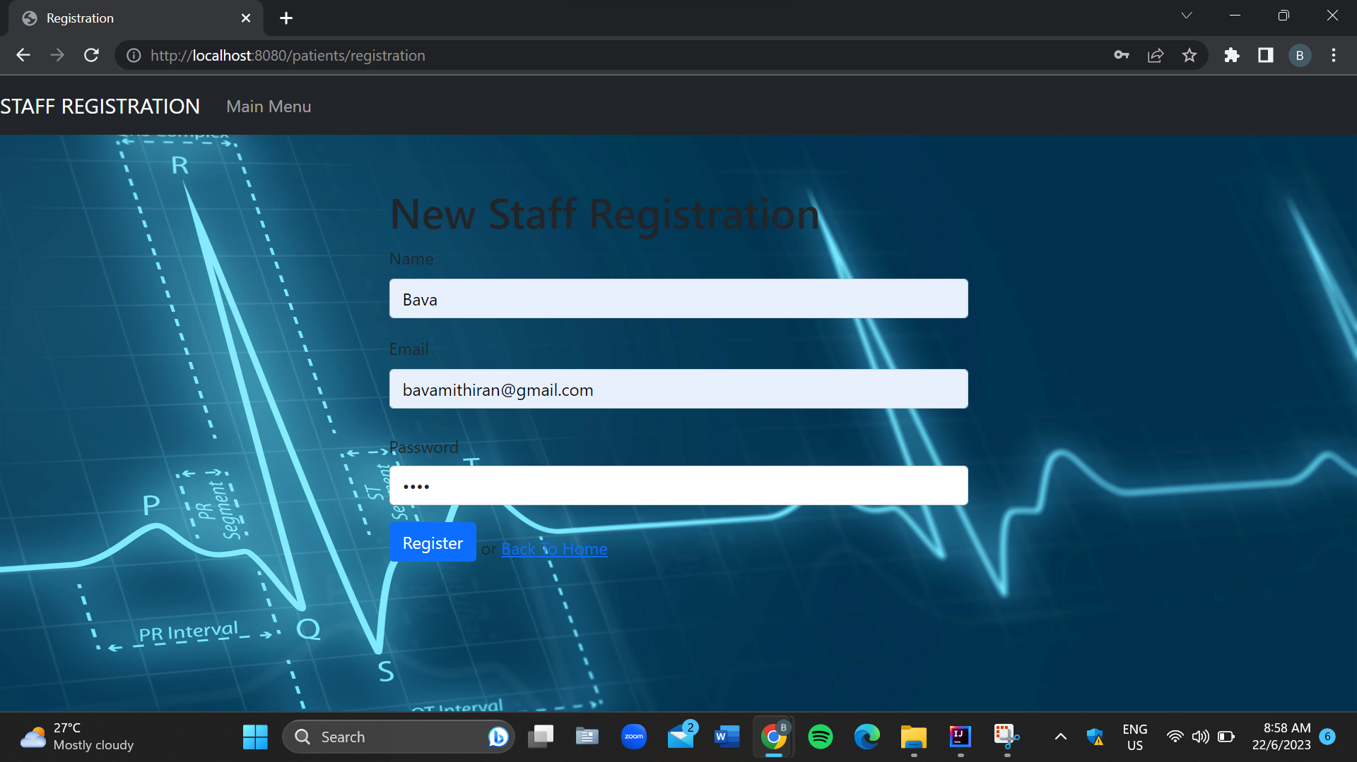

* List Of Patient Page

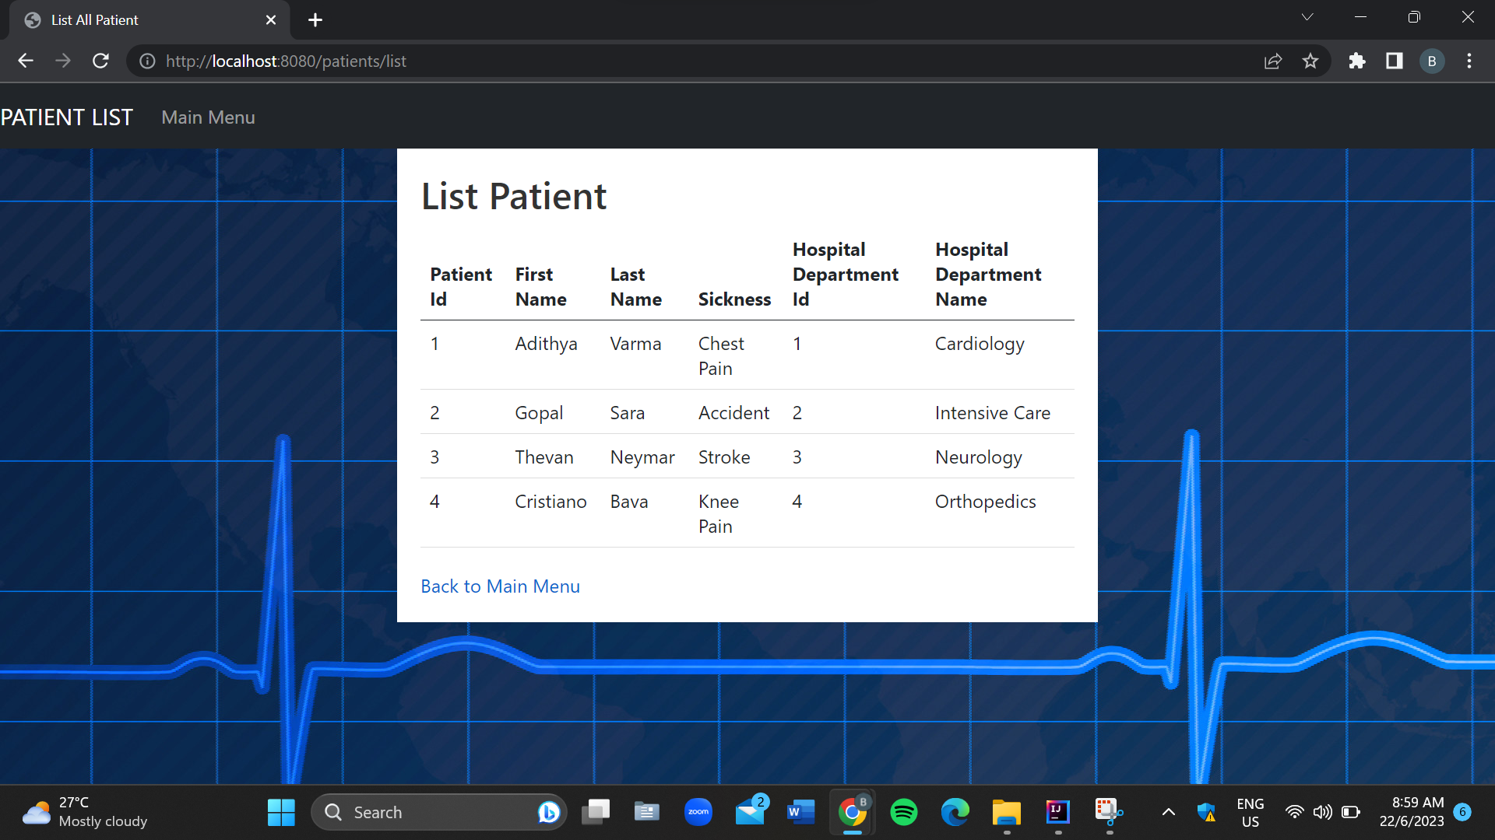

* Add New Patient Page

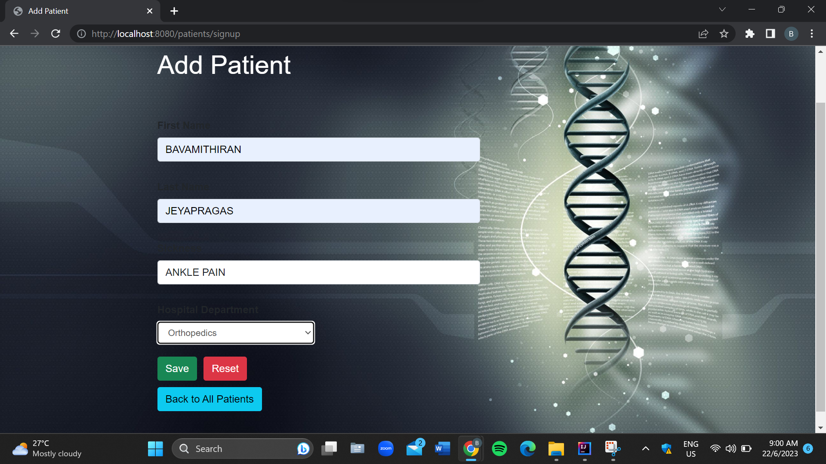

* Choose Patient To Update Page

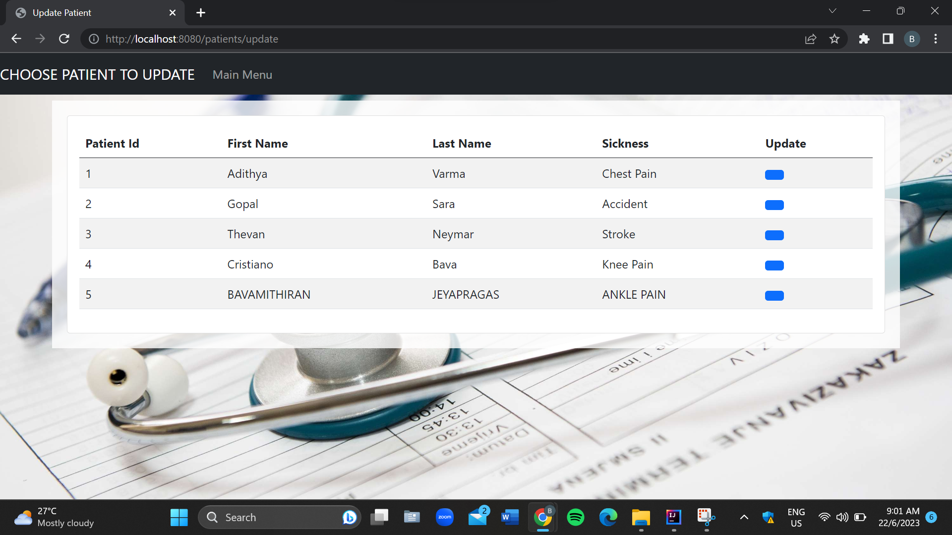

* Update Patient Page

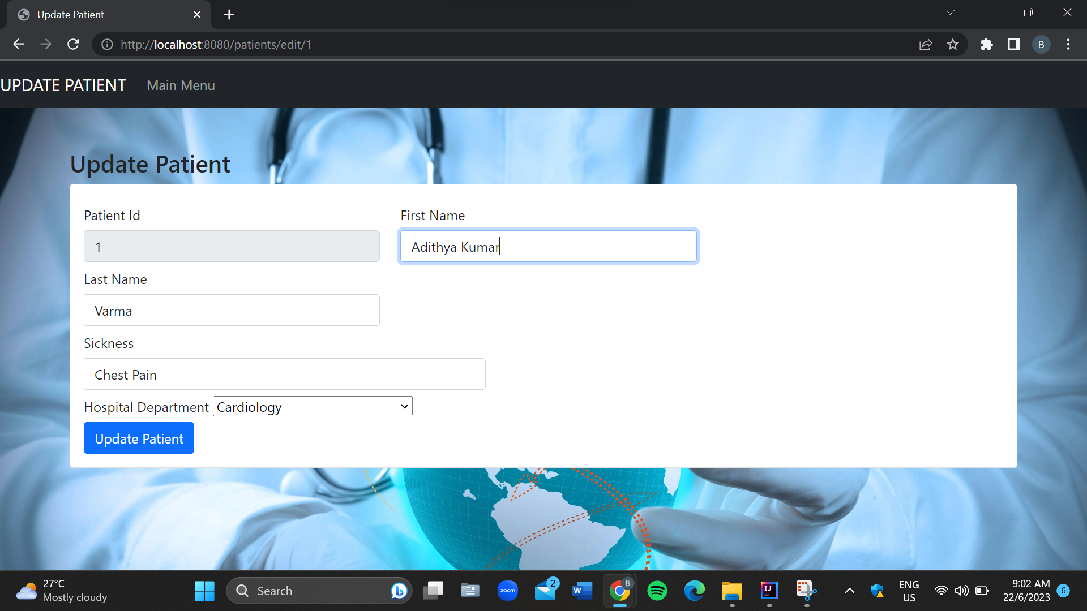

* Delete Patient Page

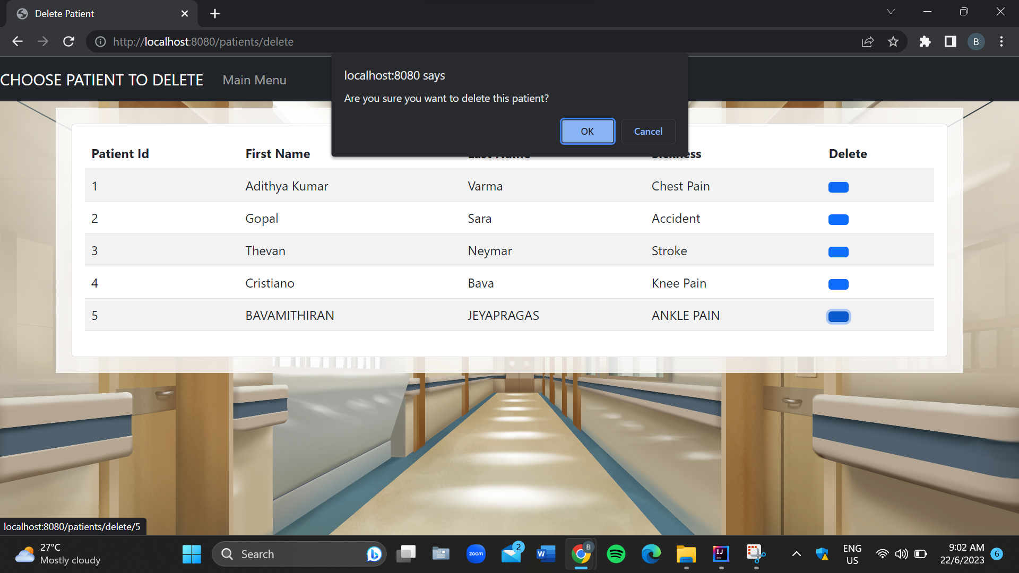

* Assign Medicine To Patient Page

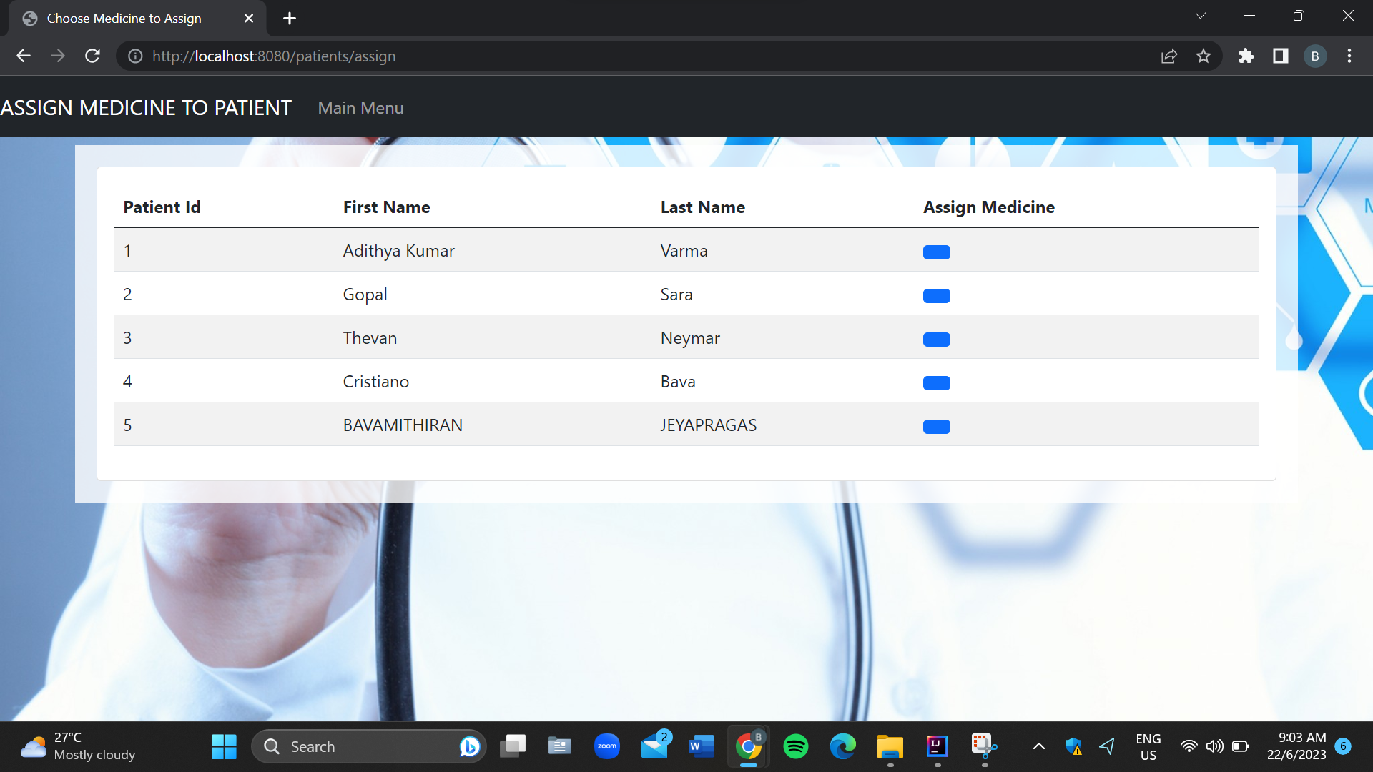

* Assign Medicine Page

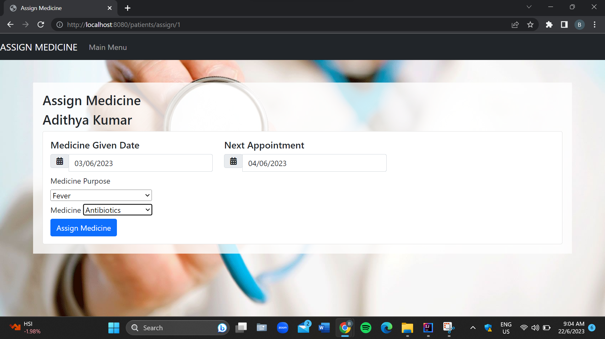

* Display Patient’s Medicine Page

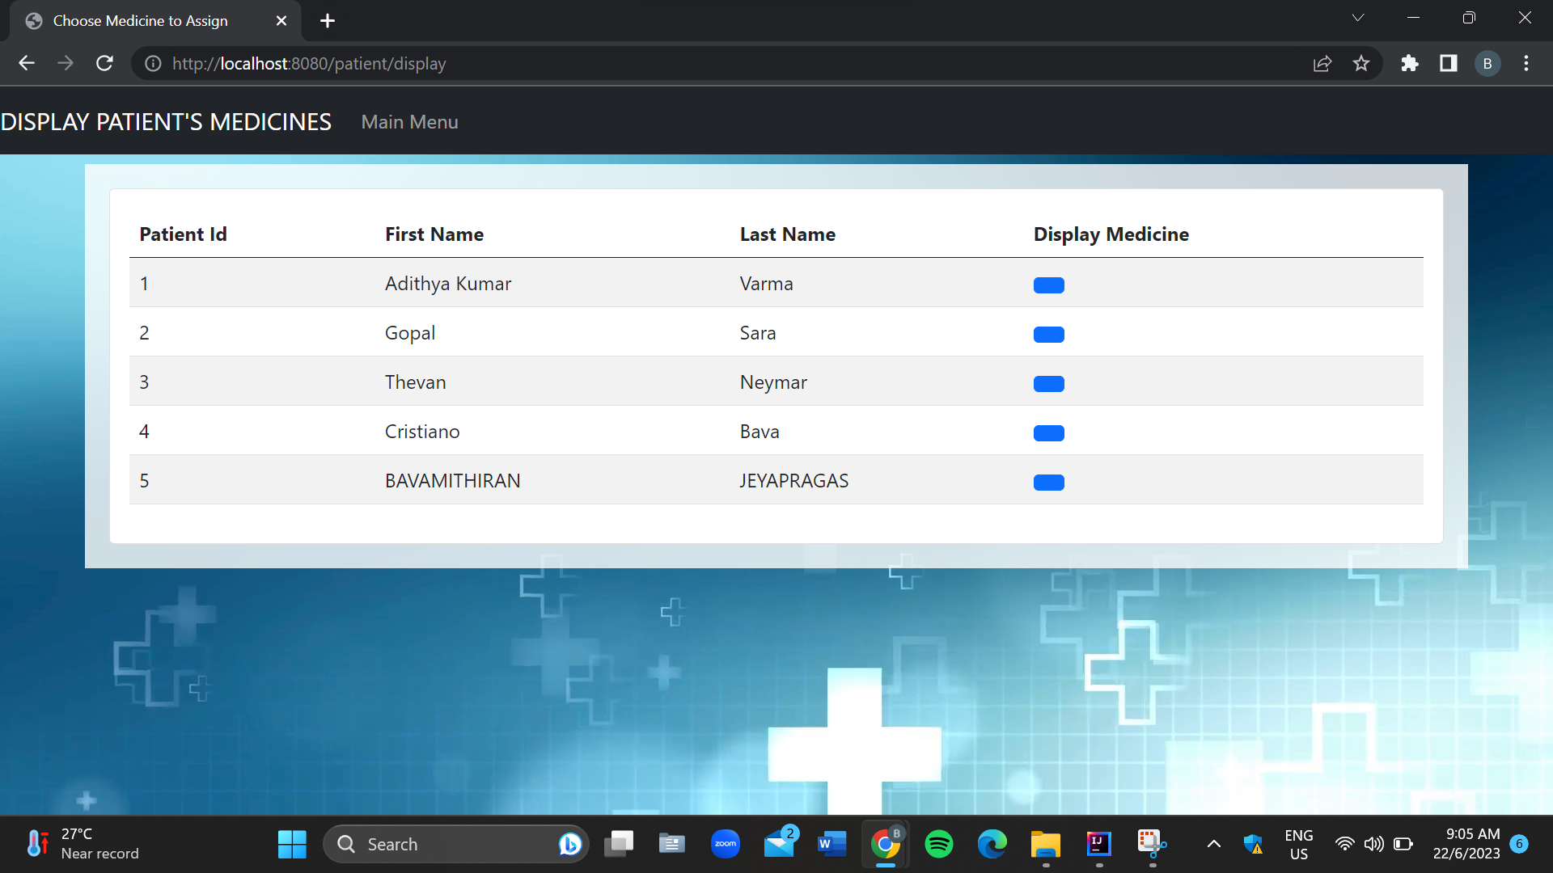

* Patient’s Medicine Page

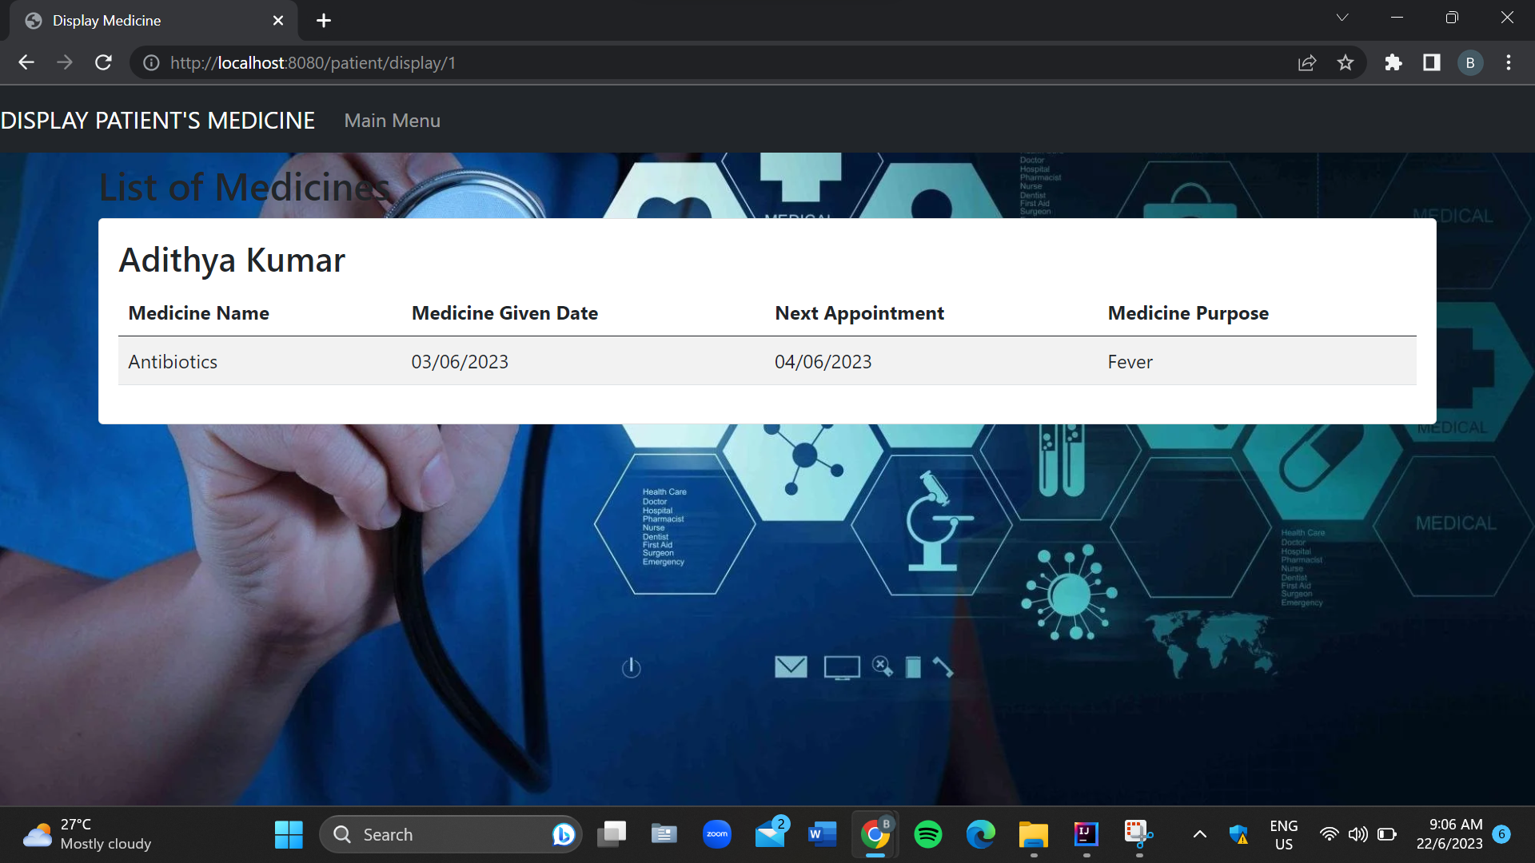

* Access Denied Page

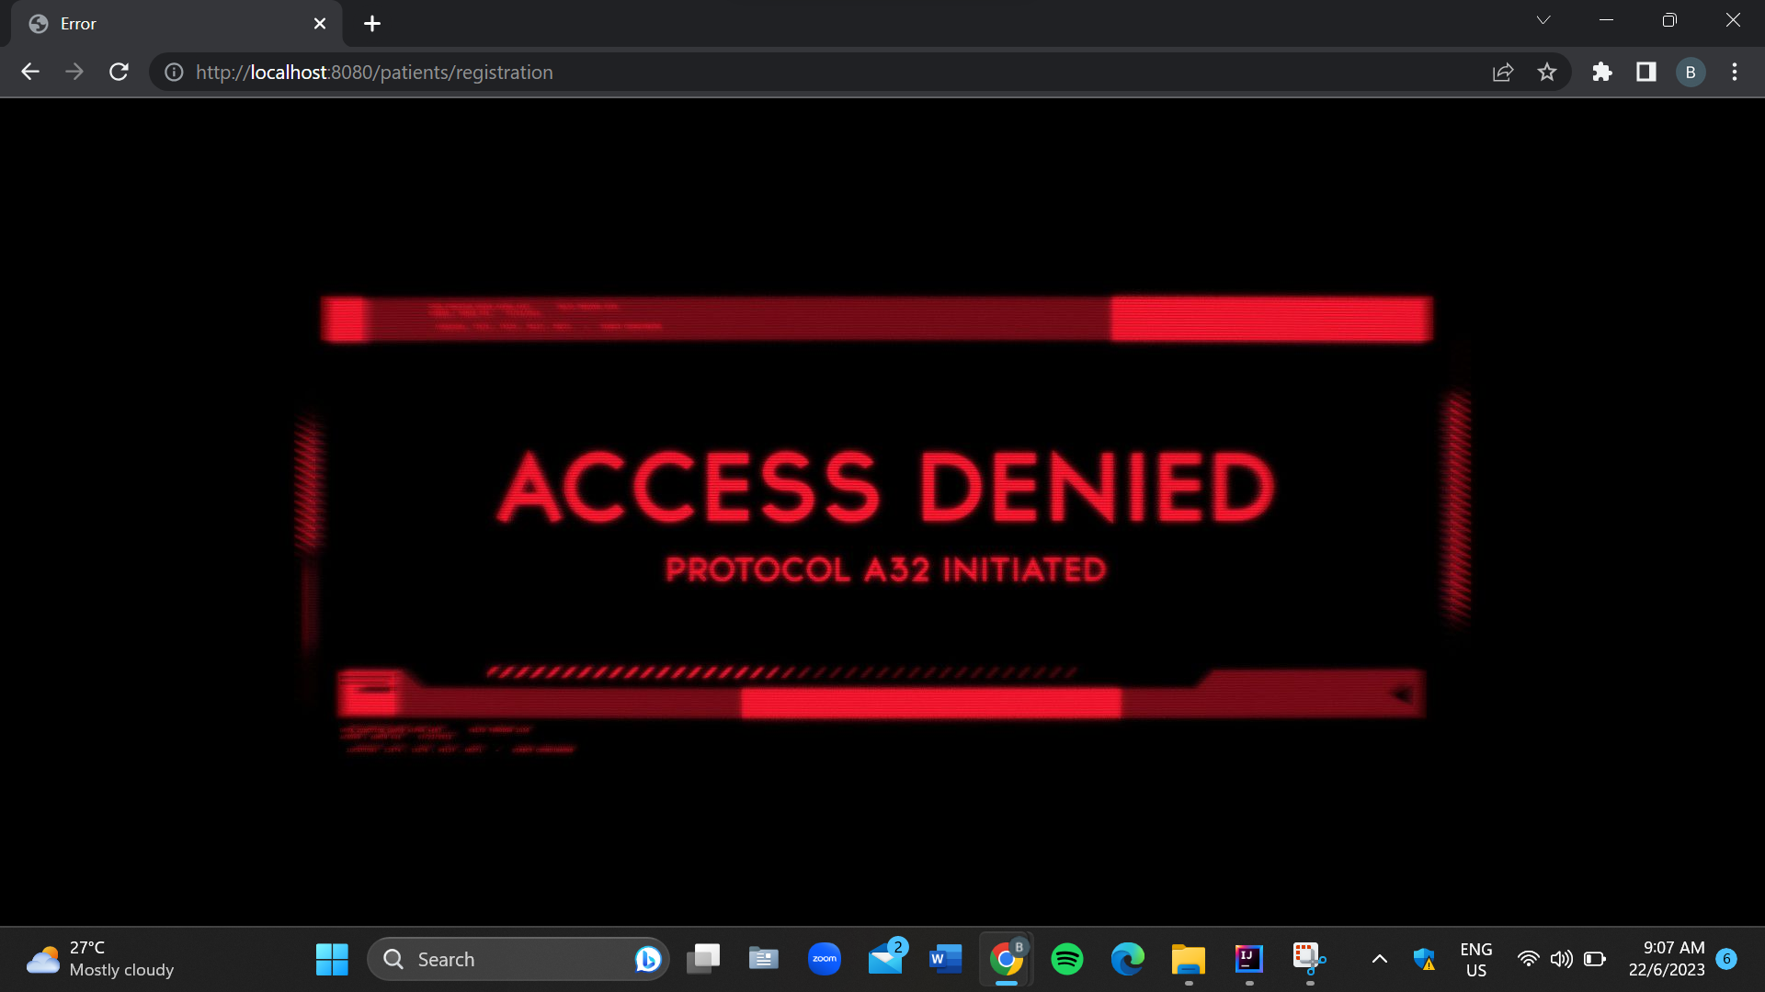

5.0 EVIDENCE OF GROUP MEETING AND TASK ALLOCATION

* Task Allocation Via Whatsapp

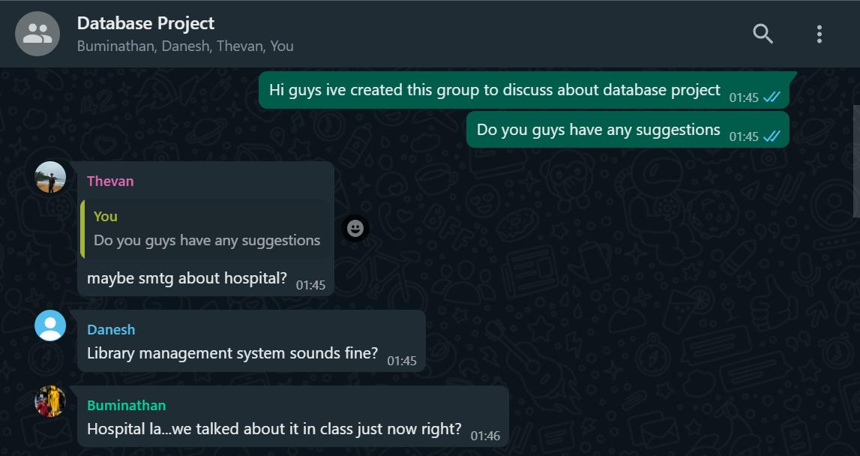

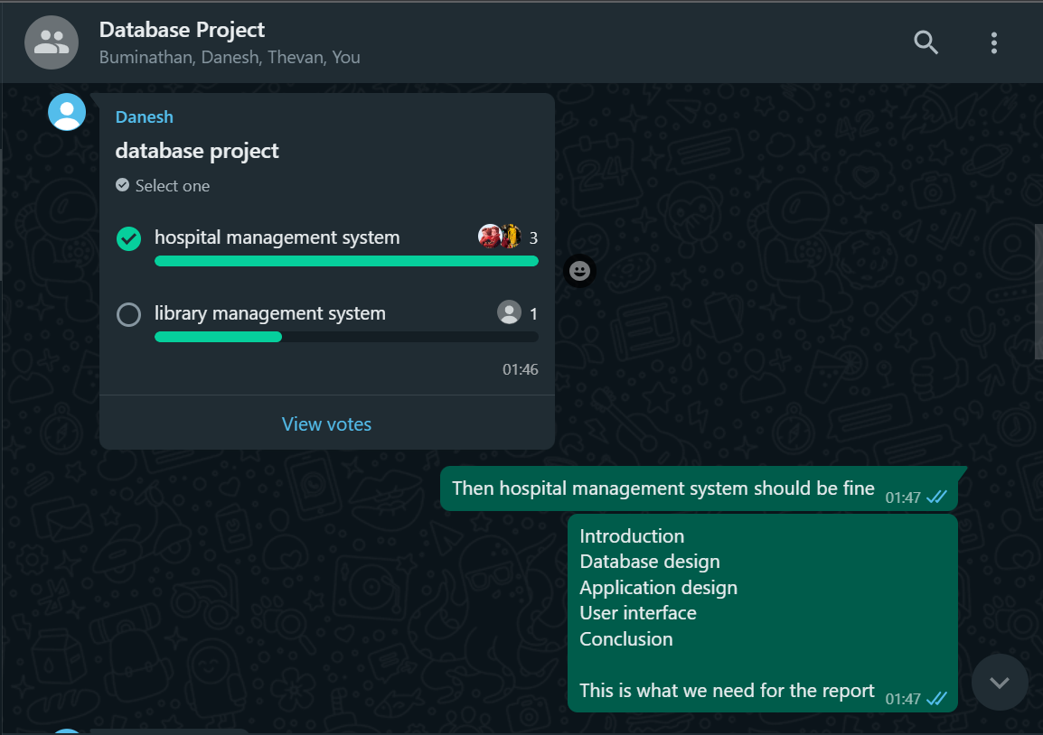

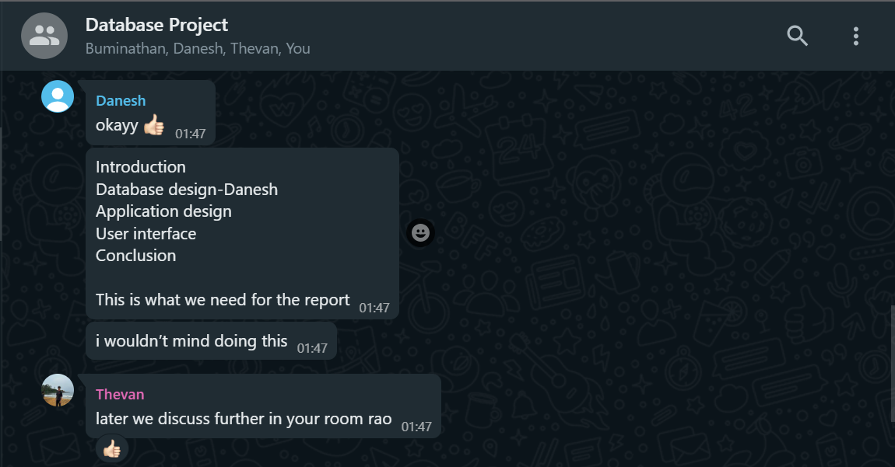

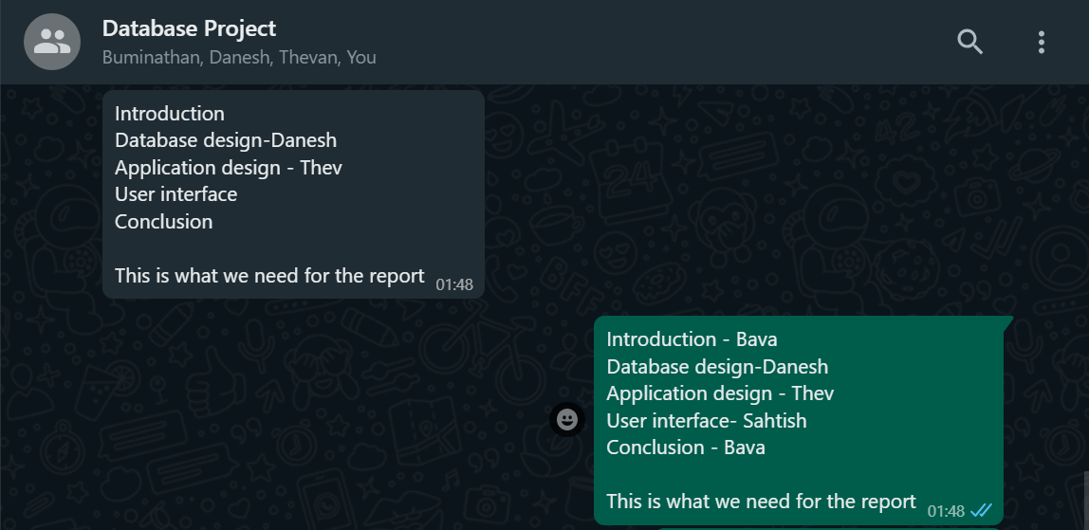

* Discussing Database Project At FSKTM

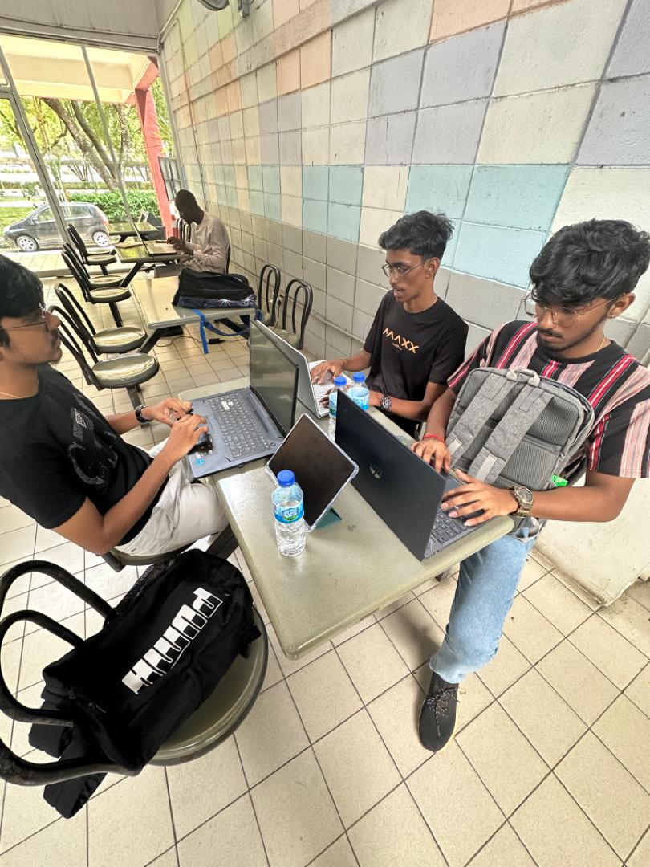

6.0 CONCLUSION

In conclusion, the development of a web-based application for healthcare data management has been successfully accomplished. The project has resulted in the creation of a user-friendly interface that streamlines the process of registering staff members, recording patient information, and managing prescribed medicines. Through role-based access control and secure authentication mechanisms, the application ensures that only authorized personnel can perform specific actions and access sensitive data.

The web-based nature of the application enhances its usability and accessibility, allowing doctors and their staff to access the system from any device with an internet connection. This feature promotes flexibility and efficiency in healthcare data management, enabling medical professionals to retrieve patient information and update medication records seamlessly.

It is important to note that this project represents an initial implementation, and there is potential for future enhancements. Further development could include features such as appointment scheduling, integration with electronic health record systems, or data analytics capabilities to derive valuable insights. Overall, this project serves as a solid foundation for the ongoing advancement of healthcare data management systems, facilitating improved patient care, and supporting medical professionals in their daily operations.